7th Grade Final Exam Study Guide-KE**Y**

**Nature of Science**

1. **What is a variable ? Any factor trait or condition that is in an experiment.**
2. **What is the dependent variable ? The variable that is measured in an experiment**
3. **What is the independent variable ? The variable that is manipulated in an experiment. The treatment**
4. **What is a control group ? The group that does not receive any treatment in an experiment.**
5. **What are constants ? Factors that remain the same in an experiment.**
6. **Measurements** 
   1. **List the base unit for the following :** 
      1. **Mass- Grams (g)**
      2. **Length- Meters (M)**
      3. **Volume – Liters (l)**
   2. **Be able to convert between different units**
7. **List the steps of the scientific Method : Observation; Question; Hypothesis; Experiment; Gather and analyze data; share your results or if need be make changes**
8. **What is an observation? Gather information using your five senses.**
9. **What is the difference between a qualitative and quantitative observation ? Qualitative refers to characteristics or physical descriptions such as a red dress, being tall ect… Quantitative refers to numbers i.e. 3 oranges, 10 people ect..**
10. **What is an inference? A conclusion one draws based on previous knowledge**
11. **What is the difference between a theory and a law? Be able to identify each. A Theory: Well substantiated well tested explanation of an observed phenomenon. Examples include The Cell theory, Theory of Evolution by Natural selection.**

**A Law: description, usually a mathematical description, of a natural phenomenon. Examples include Newton law of Gravity, Mendel’s Law of Independent Assortment**

**Topic 1**

1. **Define the following Words and provide an example**
   * **Thermal Energy: sum of the kinetic and potential energy of all the particles in an object; thermal energy of an object increases as temperature increases.**
   * **Conduction: transfer of thermal energy by collisions between particles in matter. There is a direct contact between matter. Example- Spoon in hot tea, pancakes on a griddle, pot on the stove.**
   * **Convection: transfer of thermal energy in a fluid or air by the movement of warmer and cooler fluid or air from place to place. Hot air or fluid rises and cool air or fluid sinks. Examples: Boiling water; Forced air heater in a house, air popped popcorn.**
   * **Radiation: transfer of energy by electromagnetic waves. Examples: heat from a fire, heat from the sun, heat from a hot lightbulb; microwave.**
   * **Thermal Equilibrium: When the temperature is equal in the environment and with the object. There is no transfer of energy between the two objects.**
   * **Law of Conservation of Energy: energy can not be created or destroyed, only transferred or changed from one form to another**
2. **Describe the characteristics of a solid, liquid and a gas**
   * **A state of matter is a physical property** 
     1. **Solids: Definite shape and defined volume; particles are closely packet and ordered.**
     2. **Liquids: definite volume and NO shape of its own. Particles are tightly packed but not as ridged as a solid**
     3. **Gas: can flow, NO definite shape or volume.**
3. **Which direction does thermal energy move in a system? From a warmer object or area to a cooler object or area.**
4. **The expanding of matter when it is heated is known as Thermal Expansion_?**
5. **What is the difference between temperature and heat? Temperature is the measure of the total kinetic and potential energy in an object – a number value, use thermometer;**

**Heat- the transfer of thermal energy from a warmer object to a cooler object.**

**Topic 2**

1. **Define the following words:**

* **amplitude- a measure of energy in a wave; the more energy a wave carries greater Amplitude. Measured by looking at the distance from the crest OR trough to a normal position. Compressional wave- the denser the compression the larger the amp.**
* **reflection- When a wave strikes an object and bounces off of it. The law of reflection states the angle of incidence of the wave is always equal to the angel of reflection.**
* **refraction- Bending of a wave caused by a change in its SPEED as it moves from one medium to another. The greater the change in speed the more the wave bends.**
* **diffraction- When an object causes a wave to change direction and bend toward it. The wave passes around an object.**
* **frequency- number of wavelengths that pass a fixed point each second**
* **rarefaction- The less dense part of a compressional (sound) wave.**
* **wavelength-distance between one point on wave and similar point nearest to it (crest to crest, trough to trough, compression to compression or rarefaction to rarefaction)**
* **mechanical wave- A wave that can only travel through a medium.**
* **transverse wave- Mechanical wave by which matter moves back and forth at right angles to the direction the wave travels. Think ocean waves… Waves have crest (high point, Trough- low point.**

1. What is the difference between a mechanical wave and an electromagnetic wave? **Mechanical waves require a medium to pass through, Electromagnetic waves do not require a medium.**
2. Describe what kind of medium mechanical waves can travel through. **Solid, liquid or gas**
3. What kind of medium can electromagnetic waves travel through? **Any mediums**
4. Give one example of each: reflection, refraction, diffraction. **Reflection- mirror; refraction- pencil looking broken in the water; Diffraction- sound waves in a room**
5. What unit is frequency measured? **Measured by how many times a wave passes through a neutral point.**
6. Describe how waves (light and sound) move at different speeds through the different types of matter (solid, liquid, gas**). Light waves move faster through gasses than liquids and solids. Sound Waves move faster through liquids and solids than gases.**
7. The amplitude of a wave is a direct relationship to how much **Energy** the wave has.
8. How does the size of the amplitude in a wave relate to loudness? **The larger the amp the louder the sound wave will be.**
9. Describe the relationship between the frequency of a wave and the wavelength.

**The higher the frequency the smaller the wavelength**

1. Draw and label the 5 parts of a transverse wave.

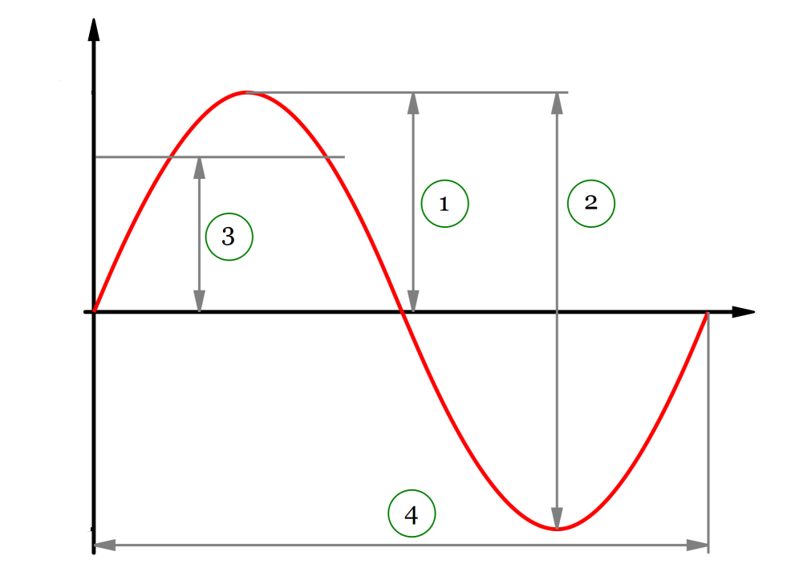

**Trough**

**Wavelength**

**Amplitude**

**Crest**

1. Draw and label the 3 parts of a longitudinal/compressional wave.

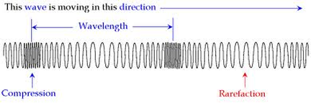

1. What is represented in the diagram below? **Electromagnetic spectrum- wavelengths**
2. What are the 2 parts (types) of this wave?- **DO NOT ANSWER THIS QUESTION**
3. Label the different wave types.

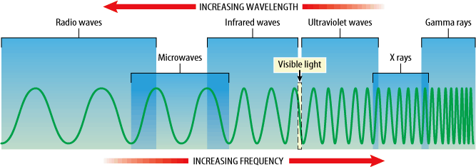

1. Give an example of each type wave or what are used for.

Gamma visible light -to light up space; projectors

radio - transmitter radios, cell phones microwave- cooking food

UV- infrared – lasers; grocery store scanners

x-ray -Pictures of bones